# CPT_Logo_Manual.jpg Introducing SharePoint 2010

**Lab Time**: 60 minutes

**Lab Overview:** In this lab you will be introduced to the SharePoint 2010 web browser interface. You will learn to log into SharePoint using your Windows user account and how to log out or change your security context without leaving the browser. You will also explore the personal Welcome Menu and other navigation tools for traversing a SharePoint 2010 site collection. Lastly you will be exposed to various core components in SharePoint that will improve your productivity as a business information user.

## Exercise 1: Logging onto SharePoint & Working with the Welcome Menu

In this exercise you will log into SharePoint and explore the personalized Welcome menu.

1. Log into your site collection using the account **Brian Cox**. This user does not have access to the site collection and therefore will be denied access.
2. Using Internet Explorer, browse to the URL of the SharePoint site collection you were provided by the instructor.
3. When prompted to login, enter [[AD-DOMAIN]]\brian in the **User Name** field and click **OK**. Use the password specified in the *Hands-On Lab Overview* document provided in the student manual.
4. Notice the error page that appears informing you that you have not been granted access to the site requested:

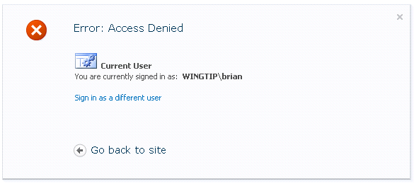

1. Click the **Go back to site** hyperlink and notice that the same error appears again.
2. Click the **Sign in as a different user** hyperlink and notice the logon prompt that appears. Click **Cancel** to the logon and note the **401 Unauthorized** error page that appears.
3. Close Internet Explorer.
4. Log into your site collection using the account **Ken Sanchez**. This user does have access to the site collection and therefore will be permitted access.
5. Using Internet Explorer, browse to the URL of the SharePoint site collection you were provided to use when working on the hands on labs in this course.
6. When prompted to login, enter [[AD-DOMAIN]]\ken in the **User Name** field and click **OK**. Use the password specified in the *Hands-On Lab Overview* document provided in the student manual.
7. Note that you can successfully access to the home page of the SharePoint 2010 site requested:

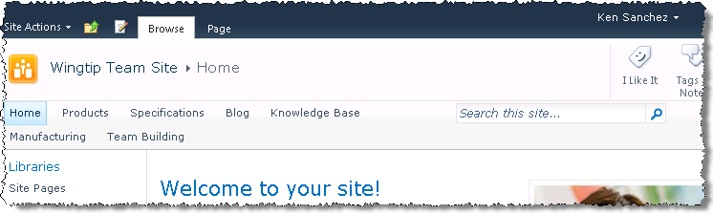

1. Each user in the organization has a personal Web site called a **My Site**. This contains information on the user from their stored profile as well as some social aspects on how to interact with them:
2. Click **Ken Sanchez** in the upper right corner of the page. Doing this causes the **Welcome Menu** to be displayed.

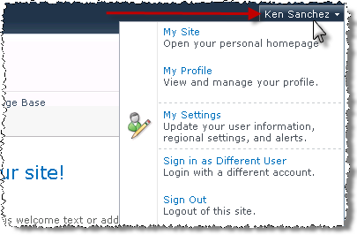

1. A drop-down menu will appear. Select **My Site** to go to Ken’s My Site. *Be patient. This may take a few minutes the first time because if the My Site was not previously created. If it was not previously created, SharePoint creates it at this time.*

**Note**: My Sites are only available if the SharePoint administrators have set up My Sites previously.

1. Spend some time looking around the various links on the Ken’s My Site.
2. Return to the SharePoint site using the back button in Internet Explorer or typing in the address you used previously into the address bar.
3. Explore Ken’s personal profile using the **Welcome Menu**.
4. Click **Ken Sanchez** in the upper right corner of the page to display the **Welcome Menu**.
5. Select **My Profile** from the Welcome Menu and notice you are taken to the Ken’s personal profile page.
6. Click the text **What's happening?** in the dialog bubble graphic next to the picture icon to enter a short statement or quote that others will see when they visit Ken’s profile page (similar to a signature or FaceBook status). Enter anything you like, for example: *Just updating my profile*.

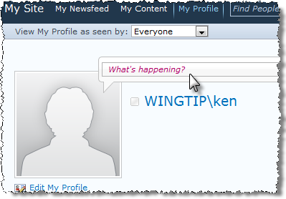

1. Click in the text box entitled **Note Board** (you may need to scroll down) and enter a short comment others will see when they visit Ken’s profile (similar to Twitter or a blog), then click the **Post** button and notice your new posting appears beneath the text box.

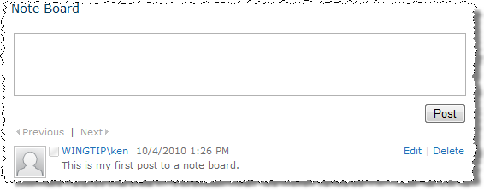

1. Click on the **Edit My Profile** hyperlink below the picture icon:

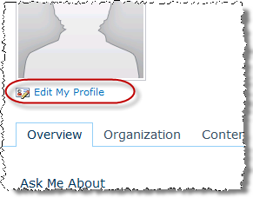

1. Use the following information to update the Ken’s profile:

**Basic Information - About Me:** I’m the site collection admin for the Wingtip site.

**Basic Information - Ask Me About:** SharePoint

**Contact Information - Mobile Phone:** 555-555-1212

**Newsfeed Settings - Email Notifications:** Send me suggestions for new colleagues and keywords – UNCHECKED.

**Note:** User profiles are stored in a central system in SharePoint known as the User Profile Service. Most classes will consist of multiple students. Because every student lab uses the same user accounts, someone may have already updated this user’s information. In that case feel free to change one of the above fields to anything you wish in order to see the changes are persisted.

1. Click on the **Save and Close** hyperlink at the top or bottom of the page to save profile changes and return to Ken’s profile page.
2. Spend some time looking around the various tabs on Ken’s profile page.
3. Return to the site collection by entering the URL of the SharePoint site collection you were provided by the instructor.
4. Explore Ken’s personal settings from the Welcome Menu:
5. Click **Ken Sanchez** in the upper right corner of the page to display the **Welcome Menu**.
6. Select **My Settings** from the Welcome Menu and notice you are taken to the user’s personal profile page.

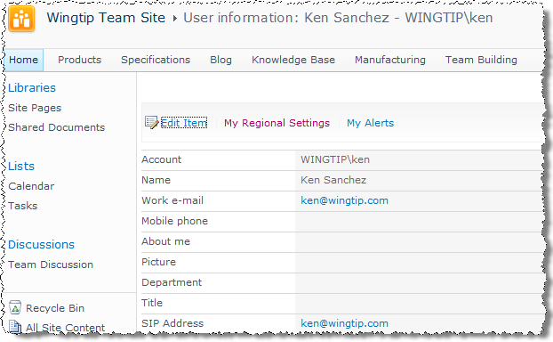

1. Click on **My Settings** and notice you are taken to Ken’s public information page. There are three (3) hyperlinks above Ken’s information: Edit Item, My Regional Settings, and My Alerts.
2. Click the **My Regional Settings** hyperlink and notice that you cannot personalize Ken’s settings until you first clear the **Always Follow Web Settings** checkbox.
3. Clear the check box and explore the options and their possible values, then click the **Cancel** button to discard any edits.

**Note**: This will deliver you back to the Wingtip Team Site.

1. Now try logging into SharePoint as a different user: **Michael Sullivan**.
2. From the Welcome Menu in the top-right corner of the page, select on **Sign in as Different User**.

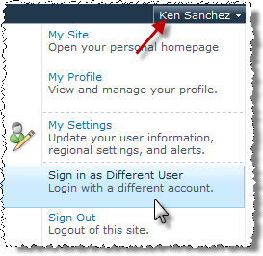

1. Enter [[AD-DOMAIN]]\michael for **a User Name** & click **OK**. Use the password specified in the *Hands-On Lab Overview* document provided in the student manual.
2. Log out of the SharePoint site:
3. From the Welcome Menu select **Sign Out** and notice the SharePoint exit page (you may need to drag the Internet Explorer pop-up message aside to see the message):

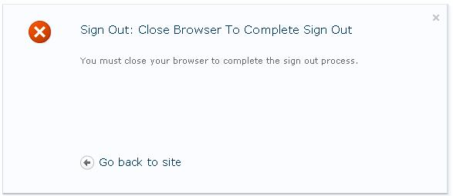

1. Now click the **Yes** button on the Internet Explorer prompt to automatically close the browser window:

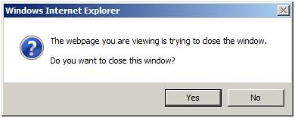

In this exercise you learned about logging into SharePoint and the personal Welcome menu.

## Exercise 2: Becoming Familiar with the Server Ribbon

In this exercise you’ll become familiar with the basic operation of the SharePoint 2010 server ribbon. SharePoint 2010 introduces a ***ribbon*** for interacting with the user interface that is very similar to the ribbon found in Microsoft Office 2007 & 2010 clients. The ribbon can be found in virtually all pages and dialogs within SharePoint 2010 sites.

1. Using Internet Explorer, browse to the URL of the SharePoint site collection you were provided by the instructor. When prompted to login, enter [[AD-DOMAIN]]\Ken in the **User Name** field and the password specified in the Hands-On Lab Overview provided in the lab manual.
2. The default ribbon for a SharePoint team site contains two ***tabs***, **Browse** and **Page**.

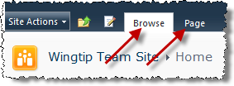

1. The ribbon changes based on the context of the current user and page. Click on the **Page** tab. You’ll see the ribbon change to show a series of ***groups*** containing ***controls***. In the following image you see a series of groups: **Edit**, **Manage**, **Share & Track**, **Page Actions** and **Page Library**:

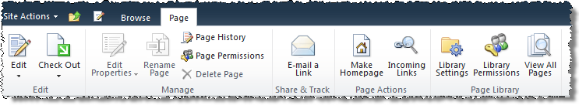

1. Some controls are available (like **Edit** and **Check Out**) while others are not (like **Edit Properties** and **Rename Page**). Controls are only available in certain scenarios.
2. Additional tabs will appear under certain circumstances. Put the page into edit mode by selecting **Site Actions » Edit Page**.

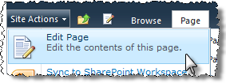

1. After the page refreshes you will notice the ribbon has some new additions. Because the cursor is in the main content area of the site where you can modify text, the ribbon now contains a new ***contextual tab group*** called **Editing Tools** that contains two new tabs: **Format Text** and **Insert**.

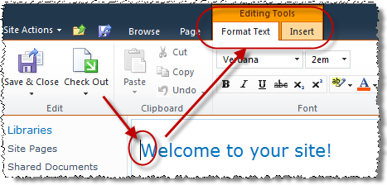

1. Additional contextual tab groups appear depending on what the user is doing. For instance, while in edit mode use the mouse to select the picture of the two men and woman looking at a laptop. Notice the **Picture Tools** appear in the ribbon.

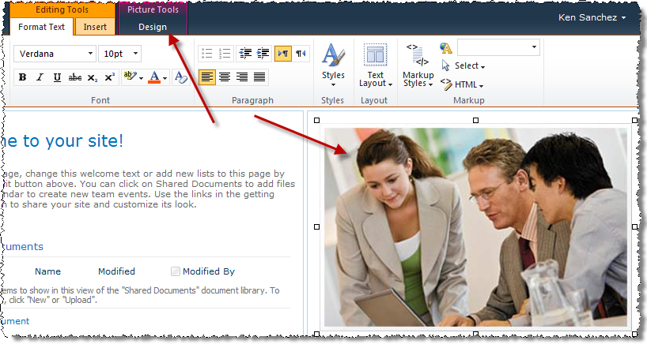

1. Try selecting the **Shared Documents** list Web Part in the middle of the page by clicking to the right of the word **Documents** and notice how the ribbon changes again.

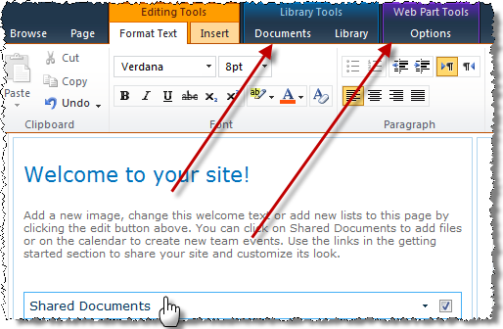

1. Using the ribbon, select the **Page** tab and within the **Edit** group click the down arrow below the **Save & Close** button to select the **Stop Editing** option.

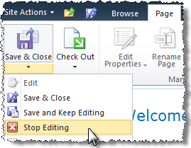

In this exercise you became familiar with the basic operation of the SharePoint 2010 server ribbon.

## Exercise 3: Navigating SharePoint Components

In this exercise you will explore the native tools for navigating a SharePoint site and the components in SharePoint that improve business information workers' productivity.

1. Log into the Wingtip Team Site as **Janice Galvin**.
2. Using Internet Explorer, browse to the URL of the SharePoint site collection you were provided by the instructor.
3. When prompted to login, enter [[AD-DOMAIN]]\janice in the **User Name** field and click **OK**. Use the password specified in the *Hands-On Lab Overview* document provided in the student manual.

If you are still on the site from the previous exercise, select **Ken’s Welcome Menu** (upper right-hand corner) and select **Sign In as Different User**.

1. Explore the title bar of the home page:
2. Click on the drop-down arrow to the right of the **Site Actions** to display the Site Actions menu. This link only appears for those users who have the necessary authority to contribute, design or manage the site and its pages. The menu choices will change for different users depending on their permissions.

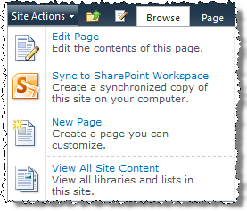

1. Click on the **Edit Page** link and notice the title bar of the page changes from the **Browse** tab being selected **Page** tab selected within the **Editing Tools** contextual ribbon tab group activated. Click the **Save & Close** button found in the **Page** tab in the ribbon even though you didn't make any changes to the page.
2. Click on the **Navigate Up** icon to the right of the **Site Actions** menu (looks like a little yellow folder with a green up arrow on it). Note the hierarchical link menu it produces to allow you to navigate up and down through the site hierarchy.

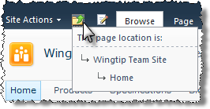

1. Click on the **Edit** icon to the right of the **Navigate Up** icon (looks like a little white sheet of paper with a pencil on it). Notice the page changes to the same **Page** view with the **Editing Tools** contextual ribbon tab group activated. Also notice that the **Edit** icon has changed into a **Save & Close** icon (looks like a little blue diskette with a blue arrow on it). Click on this **Save & Close** icon to exit **Edit** mode.

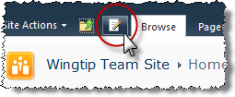

1. Change the page from **Browse** view to **Page** view by clicking the **Page** tab in the ribbon. Notice a ribbon appears that allows you edit and/or check out the Web page as well as view the page's history, use links to notify others about the page, and navigate to the pages library to view other pages in the site:

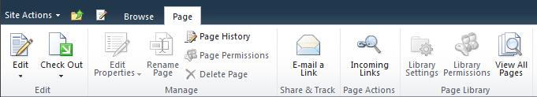

1. Click the **Browse** tab in the ribbon to go back to the default view.
2. Explore the breadcrumb trail:
3. Hover the mouse over the title of the Web site, **Wingtip Team Site**, just below the **Site Actions** menu and notice that the site title is a hyperlink. The title serves as description and navigation.

2_2.jpg

1. Click on the title of the **Shared Documents** Web Part in the center of the page to navigate to the Shared Documents library. Notice the page title has become a breadcrumb trail of navigation links you can use to back up in the site hierarchy:

2_6.jpg

1. Click the **Wingtip Team Site** hyperlink in the breadcrumb trail to return to the home page of the site.
2. Explore the Top Navigation:
3. Click on the Top Navigation tab **Products** below the site title to navigate to the products child site of Wingtip Team Site:

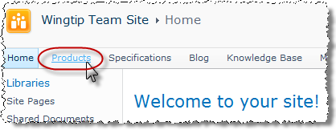

1. Notice that once on the Products child site the top navigation bar changes to reflect tabs only for the Products site and any child sites constructed under it in the site collection hierarchy.

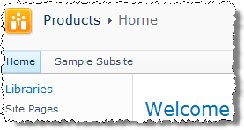

1. *So how do you get back up to the parent site Wingtip Team Site?* Remember the Navigate Up icon in the title bar of the page (looks like a little yellow folder with a green arrow on it)? Click on **Navigate Up** to produce hierarchically arranged menu of sites and click the Wingtip Team Site link! Use it to return to the Wingtip Team Site.

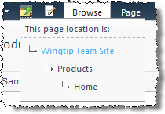

1. Notice the top navigation bar also sports a site-specific search textbox and a Help icon in the right-justified portion of the page.



1. Explore the Quick Launch Bar:
2. Click on the **Libraries** header of the Quick Launch Bar (along the left edge of the Wingtip Team Site home page).

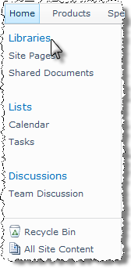

You will be directed to a page that lists hyperlinks for all libraries on this site.

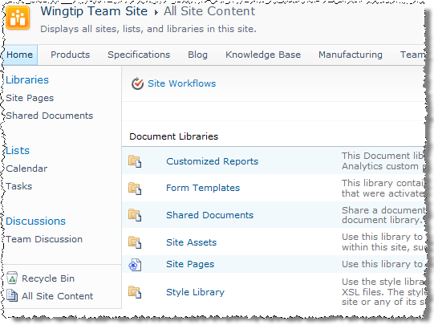

1. Click on the **Wingtip Team Site** top navigation bar tab to return to the Wingtip Team Site home page.
2. Click on the remaining headers in the Quick Launch Bar to reveal pages that list hyperlinks for lists and discussion boards on the Wingtip Team Site.
3. Click on each library, list or discussion board's title in the Quick Launch Bar to navigate to that list's page.
4. Navigate back to the Wingtip Team Site home page by one of the methods you have learned.
5. Click on the **Recycle Bin** link in the Quick Launch Bar to navigate to the user’s specific trash. Each list item or entire list object that the user deletes will be placed into this recycle bin for a limited period of time (specified by SharePoint administrators). During that time the user can restore the object if he deleted it by mistake.
6. Navigate back to the Wingtip Team Site home page by one of the methods you have learned.
7. Click on the **All Site Content** link at the bottom of the Quick Launch Bar and you should arrive at a page that contains a listing of all lists and libraries, their descriptions, and hyperlinks as their titles for quick navigation to any one of them.

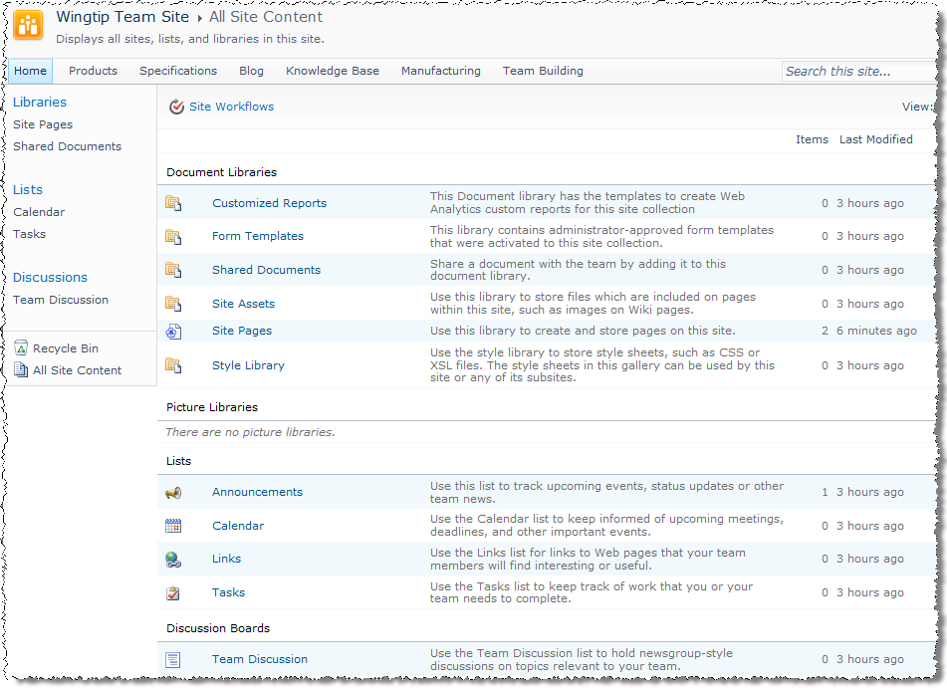

1. Explore the site by clicking into any of the list or library links, then navigating between them using one of the methods you have learned in this lab.
2. Navigate back to the Wingtip Team Site home page by one of the methods you have learned.
3. Click the **Help** icon on the right edge of the top navigation bar and explore the online help files.

In this exercise you learned about the native navigation tools in SharePoint and took a quick look at the various lists and libraries that can improve productivity.